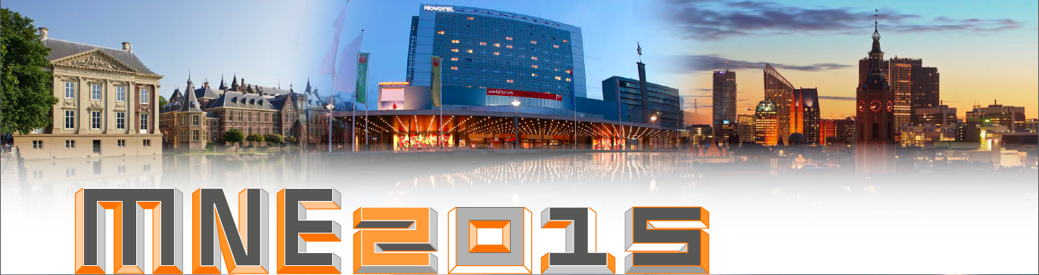
MNE2015 exhibition and sponsoring booking form

Please fill out this form, print it, sign it and send back in digital form to sponsoring@mne2015.org

Exhibition and sponsoring options
Please indicate your choice:
Bronze (no booth) ☐ € 2500,-- (excl. 21% VAT)
Silver (6 m²) ☐ € 4000,-- (excl. 21% VAT)
Gold (9 m²) ☐ € 8000,-- (excl. 21% VAT)
Option(s) €

TOTAL €

Booth selection
Please indicate your preferred booth location number. All requests will be handled on first come, first served basis.
1st choice:
2nd choice:
3rd choice:

Company information
Listing (for use in conference communications)
Company name:
Full mailing address:
Phone:
E-mail:
Website:

VAT number (for reverse charge of VAT):

Company Logo: please send us separately a high-resolution image file

Contact person
Name:
Position:
E-mail:
Phone:

We agree to pay the total amount within 30 days after date of invoice
Name:

Date:

Signature:

41st international Conference on Micro and Nano engineering, The Hague, The Netherlands, 21-24 September 2015

